Service memo
13-03-2026

Dispenser(s): Kometa > G100 Kometa
Title: Branding change Kometa

Background:

In JDE we capitalize on our iconic brands that sets us apart from our competitors, creating relevance through heritage, quality and passion for coffee.
Similarly, Evoca will be launching Gaggia branded equipment (Early 2026 the current ‘Evoca Kometa’ will be rebranded as the ‘Gaggia 100’) so we would like you to provide some background information – or in the narrative of Gaggia:

“Gaggia carries a distinguished heritage infused with authentic Italian pride and passion. The brand’s story began in 1938 when its founder, Achille Gaggia, revolutionized coffee culture by inventing the first modern espresso machine—using pressurized hot water to extract coffee and create the signature natural crema.”

Information:

In our SAP system the following change has been made:

64102891 KOMETA ES3R NL/Q JDE (VM: 9P0016)
Changed into:
64102891 G 100 ES3R/NLQ JDE (VM: 9P0809)

To avoid complexity the decision was made to only change the VM.This because only the front panel is changed.
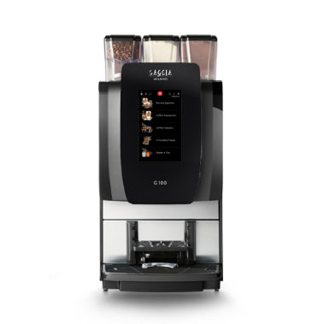
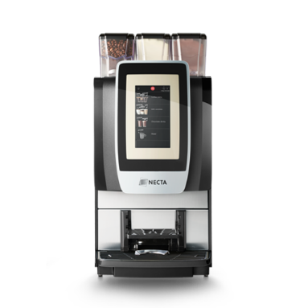
This change means that there will be some point that instead of Kometa machines, G100 Kometa machines are going to be delivered.

>>>>>>>>>>

