Service memo
26-02-2026

Dispenser(s): Necta (Kometa, Opera)
Title: Change naming/branding supplier

Background:

Our supplier Evoca has changed the positioning and naming or there dispensers.
Necta table top will be named as Gaggia xxx
Free standing will be named as Barista xxx

Changes for JDE:

Old naming Evoca | New Naming Evoca | New Naming JDE
Kometa | G100 Kometa | G100 Kometa
Opera Touch | B600 Touch | Omni XL “(B500/600)”

For Kometa the look and feel will be changed, but SAP number stays the same. This because only the front panel is changed.
The last batch Kometa’s are now entering our warehouse, so depending on the outflow soon the successor G100 will be delivered.

External changes:

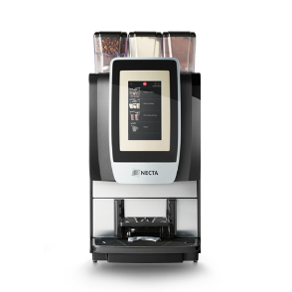
Kometa: G100 Kometa
