Service memo
30-03-2026

Dispenser(s): W100
Title: Alternative lid coffee canister

Information:

Evoca has introduced an alternative lid solution for the coffee canister.
The standard lid has two sliders, the alternative removable lids.

The alternative lid can be ordered as spare part, especially appreciated by smaller people for easier filling of the canister.
Be aware that the coffee capacity reducer (43) cannot be used anymore in combination with this alternative lid.

Standard solution: Alternative solution:

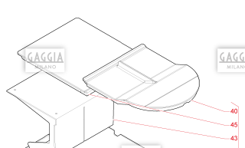
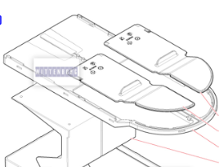

40 55129086 MOBILE SKY
45 55129087 FIXED LID

