Service Memo |  | 05-03-2021
Dispenser(s): | Cabinets
Title: | Conversing cup dispensers

Cabinets are standard delivered with 7,5oz/7C cup dispensers

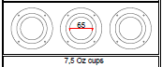

LÓR cabinets have 2 x 8oz and 1 x espresso 4oz

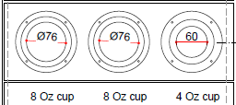

It is possible to convert them to another size:

- 7,5oz paper cups or 7C PS cups have big plastic ring and 65mm silicon ring
- 8oz paper cups have a small plastic ring and 76mm silicon ring
- 4oz espresso paper cups have a big plastic ring and 60mm silicon ring

Conversion Instruction:

- Remove the 4 bolds
- Replace silicon ring and if applicable the plastic disp ring
- Mount the 4 bolds

Spare Parts:
55115863 SILICON 7C CUPS
55115864 SILICON 8Oz CUPS
55122370 SPARE_SIL_ESPR_RING

55122371 SPARE_BLACK_DISP_RING_SMALL For cup dispenser 70mm and espresso cups
55122372 SPARE_BLACK_DISP_RING_WIDE For cup dispenser 80 mm

