Service Memo |  | 2019-007
Machine: | Schaerer Coffee Soul
Titel: | Schaerer Coffee Soul O-ring and V-seal mixing bowl instant product

Dear All,

Hereby I want to inform you that the numbers mentioned in the maintenance list for the Schaerer Coffee Soul for the instant mixer are not correct.
The wrong numbers are:
Pos 1 55101034 33.1587.4000 Seal, mixer motor
Pos 2 55101033 33.2381.7000 Seal, mixer chamber

The right numbers are:
Pos 1 55121228 078995 V-RING RD FOR MIXING CUP
Pos 2 55121229 078996 O-RING RD MIXER MOTOR

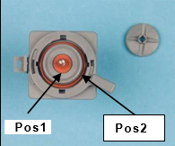

The maintenance list for the Schaerer Soul is also updated.

