Service Memo |  | 2020-003
Machine: | Schaerer Coffee Soul
Titel: | In between improvement brewer motor bracket

Dear All,

Hereby I want to inform you that from calendar week 2-2020 Schaerer implemented an improved in between brewer motor bracket (079742, SAP number 55118145) in the Schaerer Coffee Soul.
Since I recently received this information, I could not inform you sooner.

Below you will find both the changes and the required spare part numbers for converting to the brewer support from before week 2-2020 (‘old’) into the improved one.
Recommendation is to do this only if there is a problem.

Schaerer is developing a complete new brewer motor bracket implying a tool change. When the tool change is completed article number 079742, SAP number 55118145 will be updated containing all the necessary parts for a conversion (time frame: ± Nov. 2020).
As soon as this one is available I will inform you immediately.

Detailed information how to recognize the new bracket:
From ±CW02/2020 a new brewer motor bracket has been implemented in production.
- For recognition > see article number on the polycarbonate part in the red circle line.
Left: previous/old; Right: new:

PREVIOUS/OLD 55118145 NEW 55122812
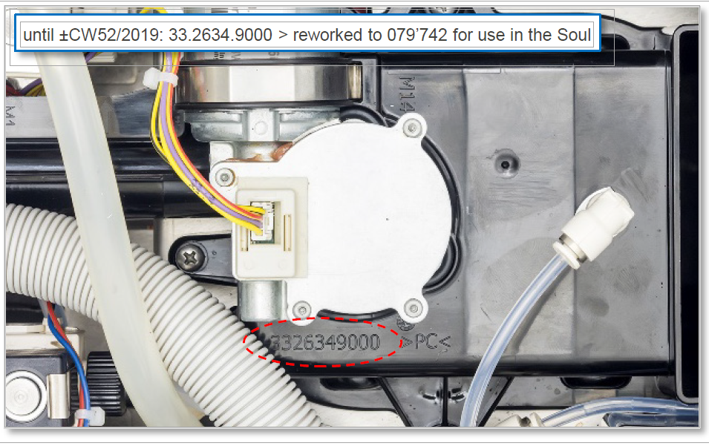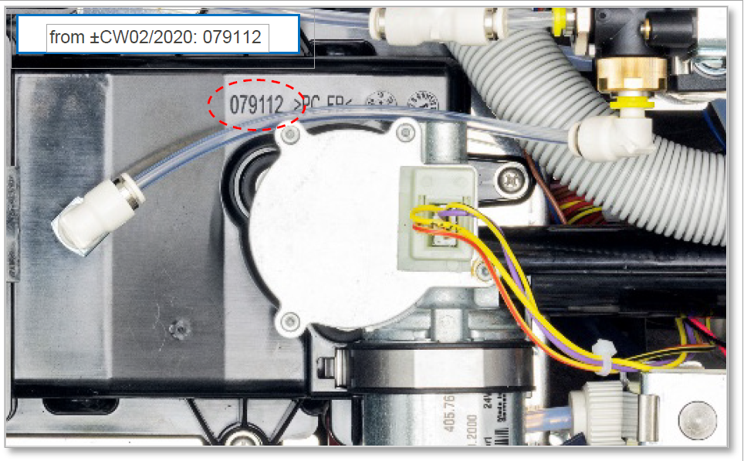
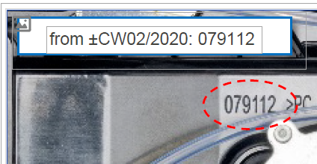
- The new bracket 079112, SAP number 55122812 has the following advantages:
  - Substantially stronger reinforcements around the motor.
  - Brewer motor can be removed (from the top) while the bracket remains in place.

- Currently a separate angled metal support is placed under the brewer motor (see picture below ). Without this metal support it is possible that, when placing the brewer back into the machine, the motor is tilted making this process impossible.
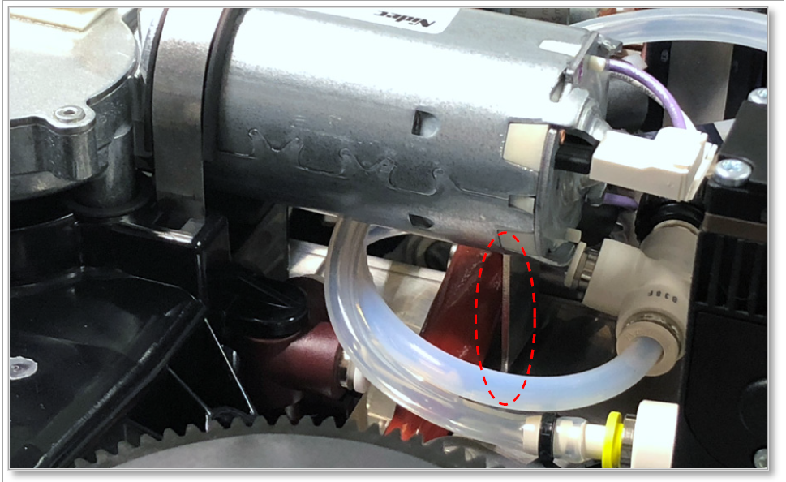
A change of tooling of part 079112, SAP number 55122812 will integrate this support into the polycarbonate part.

Currently a modification is already possible. The following parts must be ordered:
- 079112 (brewer motor bracket) HOLDER MOTOR BREWING UNIT
SAP number: 55122812
- 067939 (metal support) MOTOR BREWING UNIT SUPPORT
SAP number: 55122813
- 069986 (double sided sticky tape; 1 pc for ± 5 x 067939) DOUBLE-SIDED ADHES. TAPE 0.5X17X120
SAP number: 55122814
- 079271 (ventilator bracket) EXHAUST AIR HOPPER
SAP number: 55122815
- 079273 (rubber suspension) INSULATION MOTOR BREWING UNIT
SAP number: 55122816

